UC-One

Your business communications are about to get a lot simpler.
UC-One is a communications and collaboration Software as a Service (SaaS) for calling, messaging, and meeting with anyone, from any device. It includes HD video, voice, messaging, file sharing, screen sharing, and conferencing in a single easy-to-use cloud application that integrates with other cloud business applications.

UC-One provides a seamless and consistent communications experience on a PC, tablet or smartphone - ideal for organizations of any size with geographically dispersed teams and mobile employees working at the office, at home, or on the go.

1

Key capabilities
UC-One enhances three of the most common scenarios for communicating in the workplace: calling, messaging, and meeting. Here’s how it facilitates reliable collaboration among everyone in your company and with people outside your company.

Calling
» Business calling – From our mobile app you can place and receive business calls using VoIP and the cellular network using your business phone number.
» One number – You publish one business phone number and all your business calls will go to the device of your choice: desktop, tablet, or smartphone.
» Wi-Fi Calling – From our mobile app you can place and receive business calls using VoIP and the cellular network using your business phone number.
» HD Video – High-definition video and wideband audio codecs help virtual teams build trust when face-to-face meetings aren’t possible
» Presence status – UC-One keeps you “in the know” of your colleagues’ availability status (available,
busy, away, or on the phone), saving you time and eliminating the guesswork out of communicating.
» Corporate directory – You can easily access your corporate directory, enabling you to find colleagues within seconds with simple search from any device.
» Click-to-call from Website – Use your UC-One phone number to receive calls from your company website and deliver better service to your visitors.
» Dial into a video conference – Join a video conference bridge or Webex® meeting from UC-One using the SIP Uniform Resource Identifier (URI) for the conference system.

Messaging
» Direct and group chat – Exchange messages instantly with a colleague or a team and minimize email overload.
» File sharing – Share files in as much time as it takes to send a chat. UC-One is
compatible with all major file types. Preview files without opening them as well.
» Universal search – Find what you need by searching across all of your content quickly.
» History – Available so you never lose track of your chats and all are safely archived
» Offline mode – View your messages and listen to your voicemail when you don’t have a data network connection, so you can stay productive at all times.

» Application integration – While you’re chatting, everything you share in common with a colleague or a group, like emails
or files from other business applications, is there at your fingertips. UC-One is
pre-integrated with Office 365, G-Suite, Salesforce, and other popular applications.
» Team collaboration – See the team collaboration section further in this document for additional features that apply to messaging.

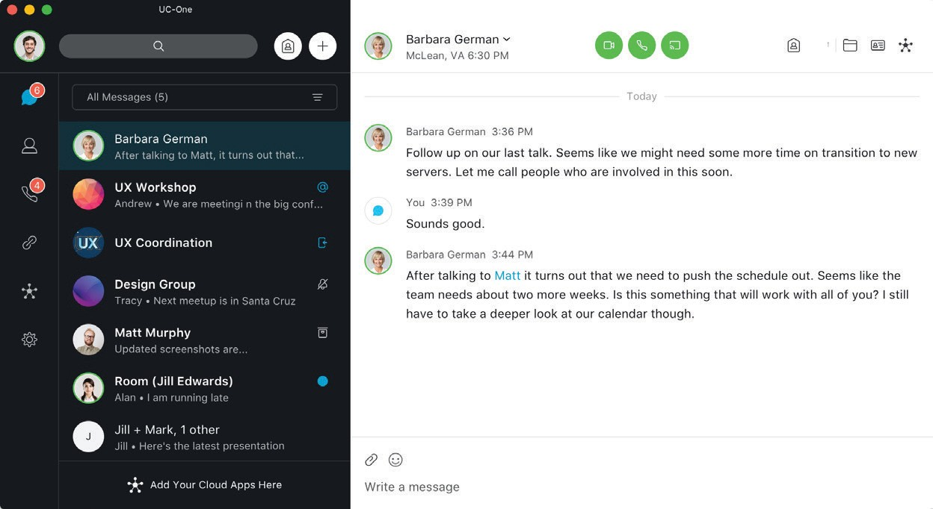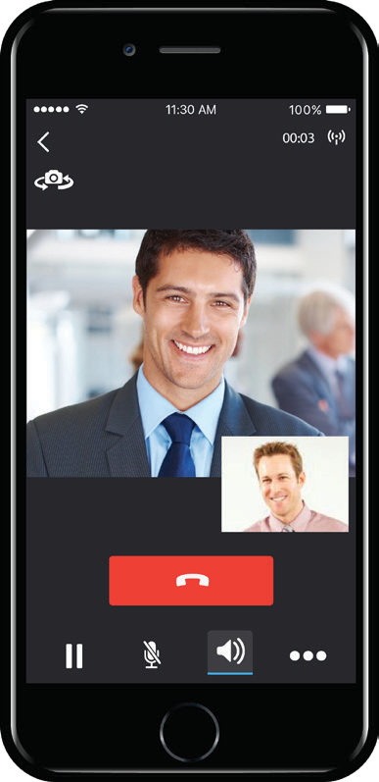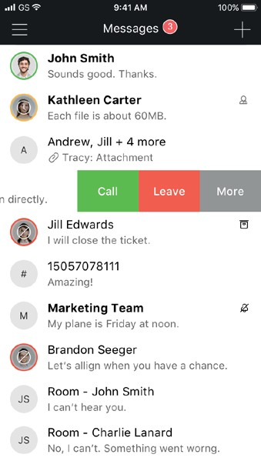

Meeting
» Virtual meeting room – Everyone with UC-One has their own private and secure online meeting space where teams can participate in HD audio, video, messaging,
and screen sharing collaboration. Colleagues and guests can easily join without the hassles of dial-in numbers and passcodes.
» HD video conferencing – High-definition 1080p at 20fps video increases engagement and minimizes distractions during meetings. Virtual teams can meet as naturally online, as when they’re together in the same room.
» Screen sharing – Share your entire screen or just a specific app or a document, without additional downloads or separate web collaboration apps. Sharing can be done from your desktop and everyone can view from desktop, tablet, or smartphone. View full screen or zoom in or out for a better viewing.
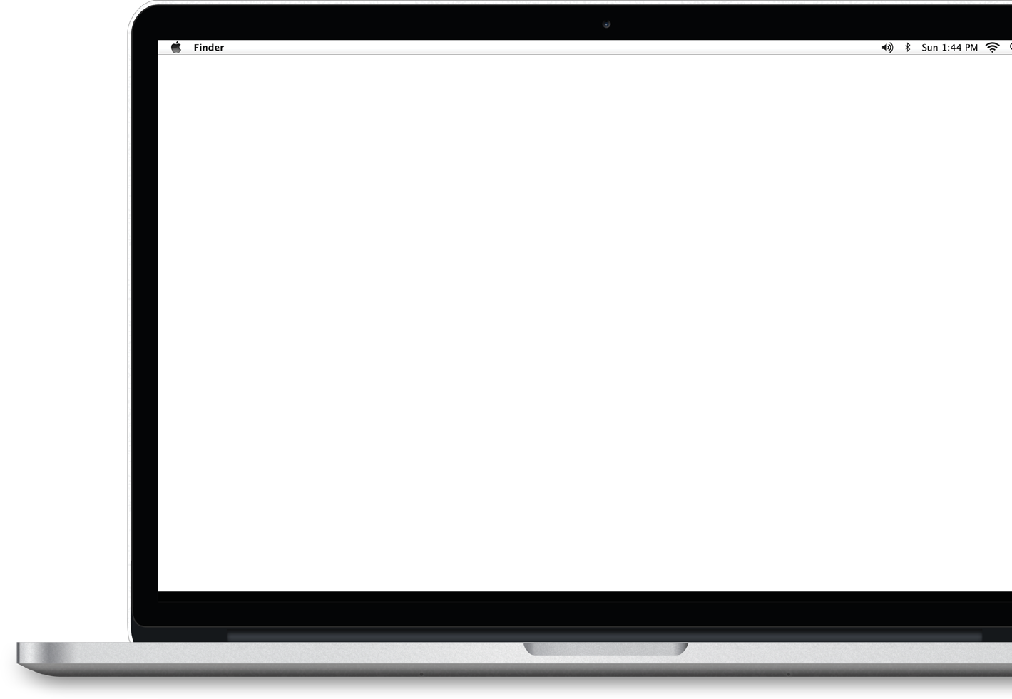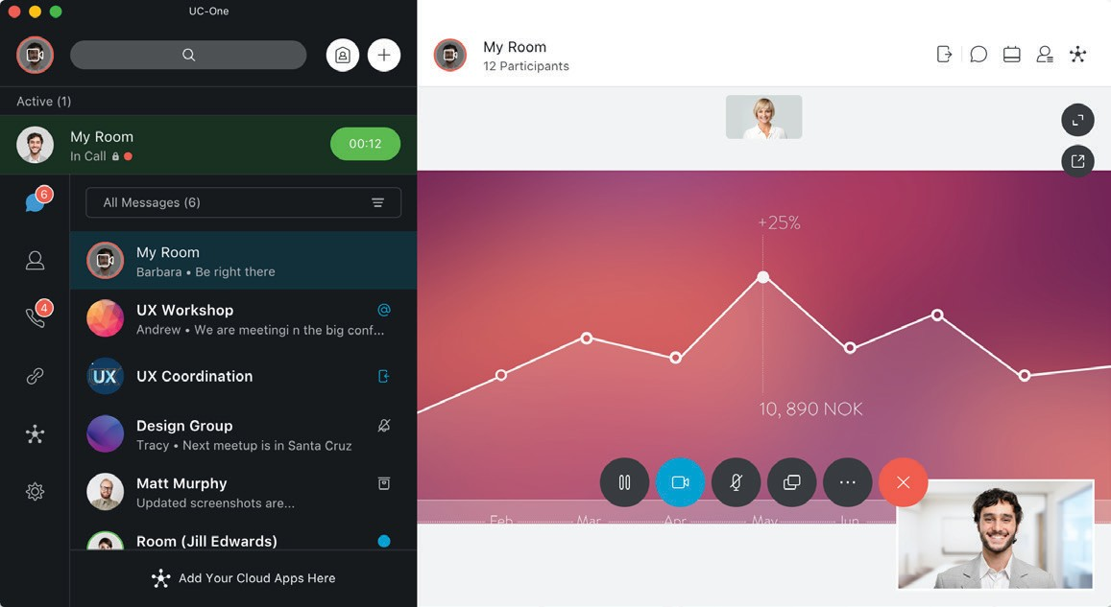» Group chat – During meetings, desktop and mobile participants can chat with one another to increase meeting effectiveness.
» Guest collaboration – Invite external people to join you in a multimedia collaboration session. Mobile working
» Team collaboration – See the next section, team collaboration, for additional features that apply to meetings.

Team Collaboration
» Spaces – Enjoy persistent, dedicated workspaces organized around the people and subjects that make sense for you and how you work.
» Call, message, meet, share – Do all of it, right from within a specific space.
» Always on – With persistent spaces, you never lose your content. Search across people, spaces, messages, and files to find what you need quickly and easily.
» Smart notifications – Customize your alerts and eliminate distraction.
» Universal search – Easily search across spaces, people, messages, and files.
» Moderator control – Control who is joining specific spaces. Only you
can add people to the space, and you get other privileges like being able to delete people’s messages or files.

79% of knowledge workers work in dispersed teams
They average over 60 meetings per month and 40% of their meetings are online
A meeting that starts five minutes late costs a company 8% of that meeting

Mobile Working

80% mobile workers use text messaging for business
59% of employees use mobile devices to run line-of-business applications
70% of mobile professionals conduct their work on personal smart devices
» Any device – UC-One works on PC, MACs, and iOS and Android tablets, and smartphones so you can be highly productive from anywhere.
» One phone, multiple purposes – UC-One is ideal for using your personal smartphone for business use. It enables you to use your business identity when calling a customer so you maintain a professional image while keeping your mobile number private.
» VoIP calling – You can place and receive business calls using VoIP while roaming to avoid high roaming charges.
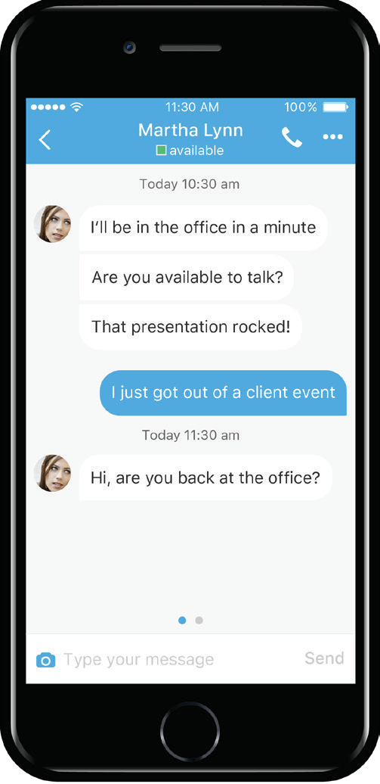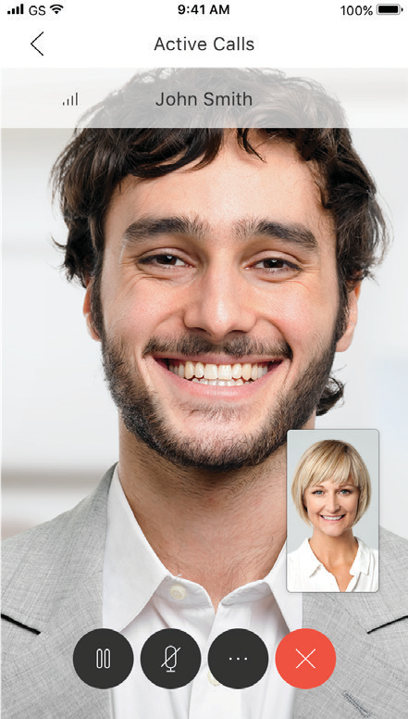» Move calls – Seamlessly pull your active call from your desktop to your mobile and vice versa, without interruptions or disconnects.
» VoIP handover – UC-One automatically keeps your VoIP calls as you move between data networks, such as from Wi-Fi to LTE.
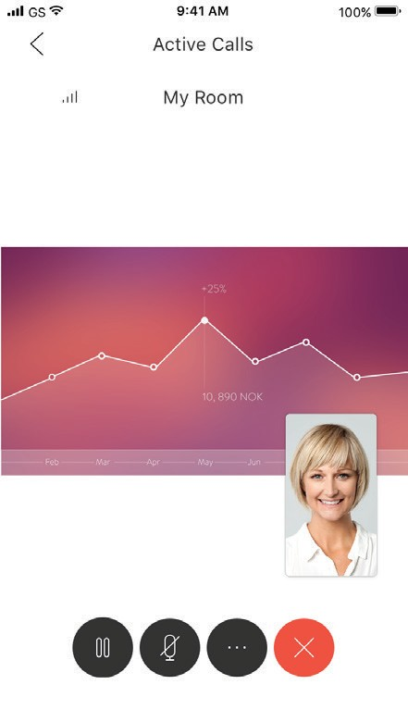» Multiple calls – You can handle two calls at the same time and even merge them into a 3-way conversation.
» Access to your office – Our mobile app provides you with easy access to your corporate directory and other business applications, keeping you connected when you’re on the go.

Business application integration
» Pre-integrated business apps – UC-One unifies with popular business applications, making it easy to find key information stored in those apps, while streamlining communications and business processes. Pre-integrated apps include Google G Suite, Microsoft Office 365, Outlook,
Box, Salesforce, Concur, and Twitter.
» Micro-app views – Your pre-integrated apps are accessible within the UC-One window, saving you time and minimizing app switching while you’re communicating.
» Quick actions – You can easily view and work with your apps, including emails, calendar events, files, sales opportunities, and even social media postings while you’re communicating in UC-One.
» Emails and calendar events – Filter Google and Microsoft items for emails and calendar events, and perform functions such as Mark as read, Archive or Delete emails or Accept calendar invites.
» Files – Filter drive files from Box, Google,
or OneDrive and launch files with one click.
» Tweets – Filter Twitter information based on My Tweets, Retweets, and Mentions, and perform functions on a tweet such as Retweet and Like.
» Sales Accounts - Filter Salesforce items based on All Accounts or Specific Opportunities, and perform
functions on an opportunity such as Add Note and Change Status.
» Tasks - Filter Google tasks, and perform functions such as Add a task, Change a task due date, Assign/Re-assign a task, Mark task as complete, Delete, and Edit.

Content in common
» Unified view – You can easily find all your files, calls, messages, and colleagues in one place, keeping you focused
and minimizing the need to shift your attention away from your conversation.
» Content you’ve shared – Everything you’ve shared with a colleague in the pre- integrated business apps is dynamically displayed while you’re communicating, bringing relevance and context to your conversations and removing the chaos of app switching and searching for files.

We switch tasks on our computer 566 times a day
We spend 20% of our time weekly searching and gathering information
44% of workers do not find the information they need to do their jobs

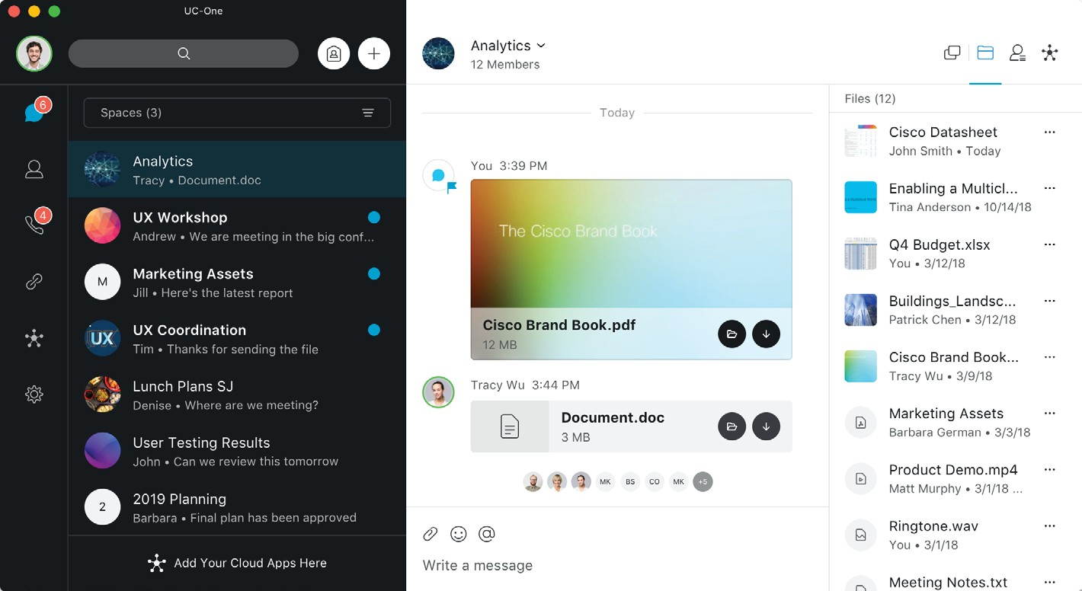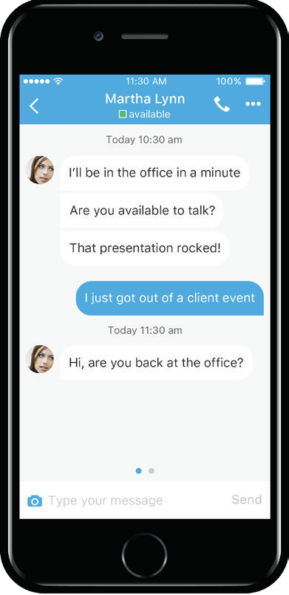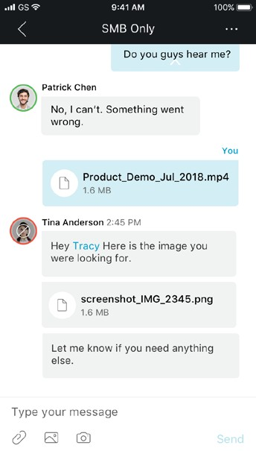Datasheet

Why UC-One?
Improved productivity Companies that deploy unified communications experience a 72% increase in business performance.

Better collaboration
91% of IT executives see improved collaboration after UC is implemented.
Faster problem solving 88% of UC buyers reported
significantly faster problem resolution.

Datasheet

Requirements of UC-One
Devices and operating systems desktop
» Mac OS 10.10 Yosemite, 10.11 El Capitan, 10.12 Sierra, 10.13 High Sierra
» Windows 7 SP1, 8/8.1, 10 (classical view only)
Tablet and smartphone
» Apple iOS 10.3 and newer
» Android 4.4 and newer
Feature and language support
Languages
» English, Chinese-Simplified, Dutch, French, French-Canadian, German, Italian, Japanese, Korean, Portuguese (European), Spanish (European and CALA)
Meetings
» Up to 30 audio and video participants per conference call
» Rendering up to 6 participants on desktop (5+1 tile-view)
and 4 (2+2) on mobile

Cisco Capital
Flexible payment solutions to help you achieve your objectives
Cisco Capital® financing makes it easier to get the right technology to
achieve your objectives, enable business transformation, and help you stay competitive. We can help you reduce the total cost of ownership, conserve capital, and accelerate growth. In more than 100 countries, our flexible payment solutions can help you acquire hardware, software, services and complementary third-party equipment in easy, predictable payments. Learn more.

Want to learn more about how to improve collaboration in the workplace?
Contact us to learn more.

