Application overview

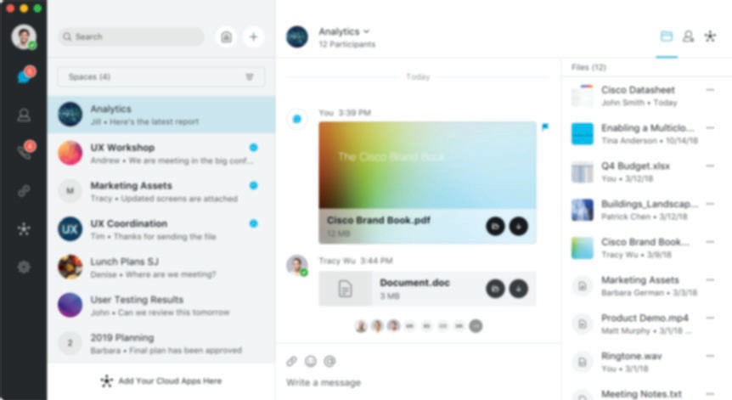Download and run the executable le, then sign in. The application has four main areas:

Side menu

List area, showing conversation list

Detail area

Activity column

The list area

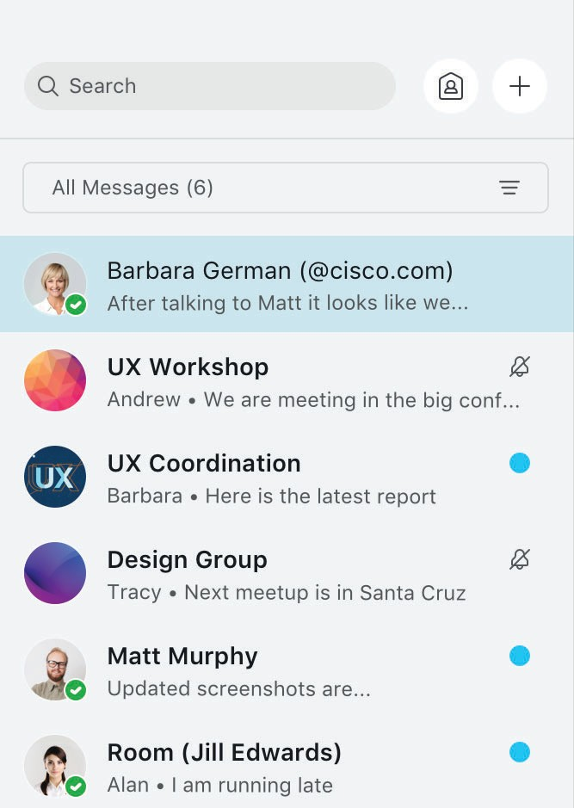Displays the list of messages/contacts/calls (whatever you chose from side menu):

Controls area for adding new items, searching through items, or filtering items

The selected item opens in the detail column

List area shows the whole list, search results, or filtered list

Icons and overlays that show item status, eg. muted notifications, unread messages
The side menu Navigate between menu options here:
Messages (selected mode) (6 unread)
Contacts

Calls (4 notifications)

Web links

Hub integrations Application settings

The detail area

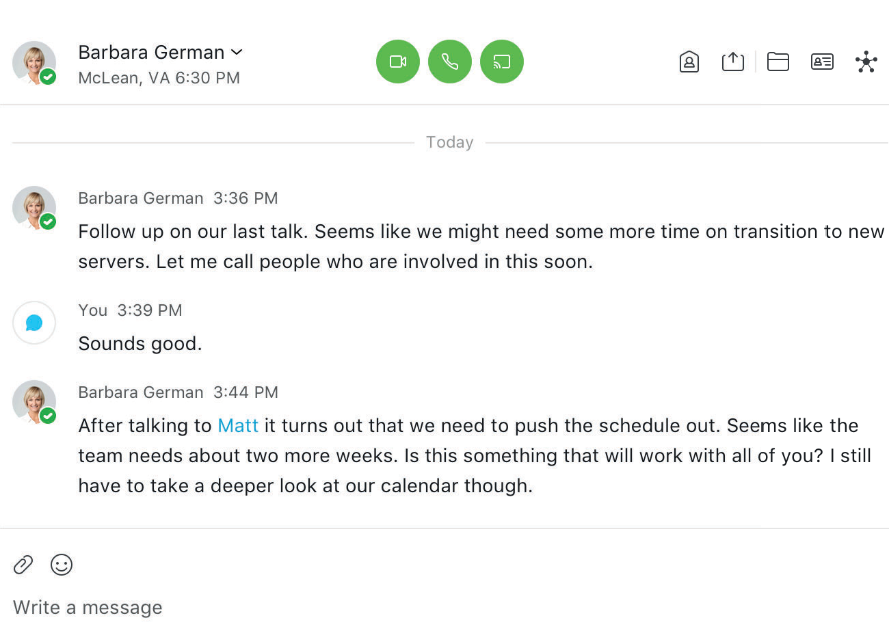Displays the contents and controls of the selected item:
Active conversation with Barbara German
Hover avatar to see contact card
Details depend on side menu option, eg. for chat it is message history

Write message

Communication options

Click your avatar to see your profile, change your
presence, or sign out
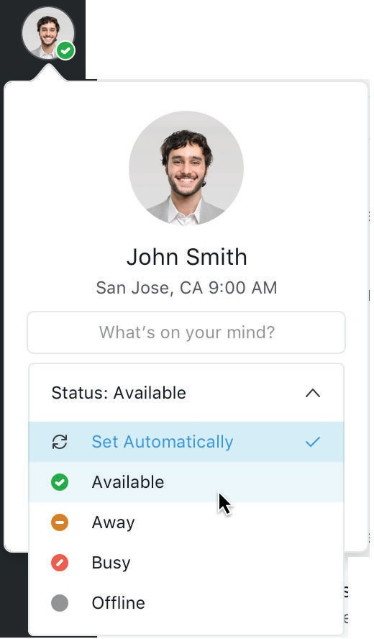

Related activity

Contacts

Select the Contacts icon on the side menu to manage your contacts:
Calls
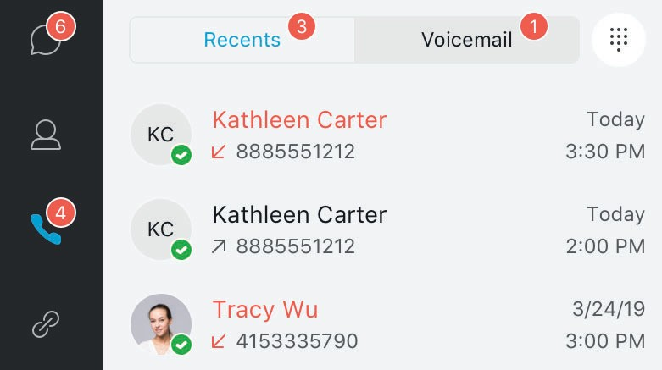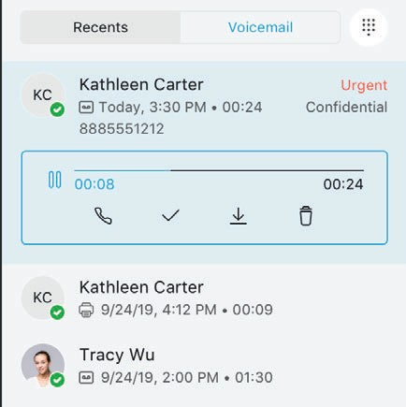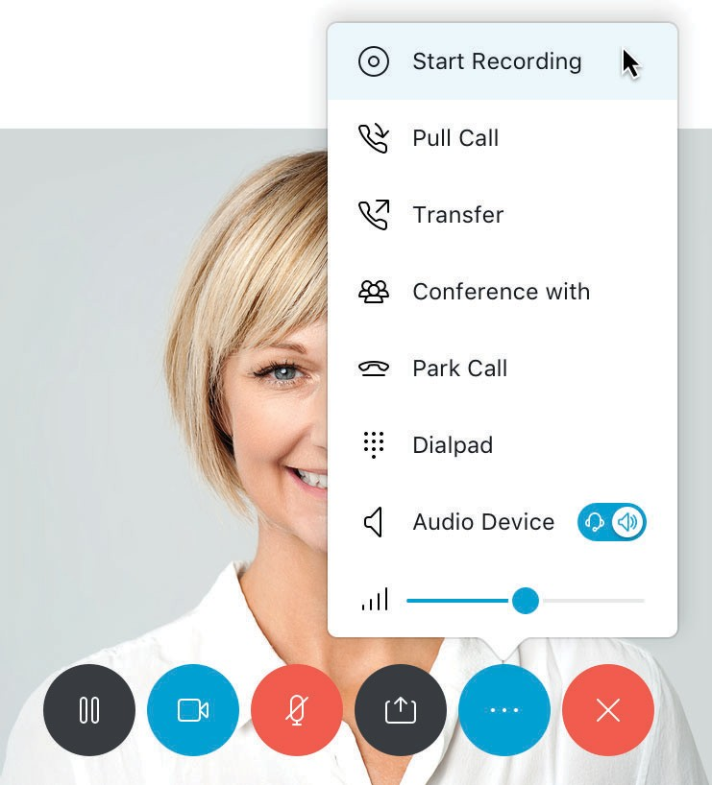Select the Calls icon on the side menu to make calls, check call history, and manage voicemail:

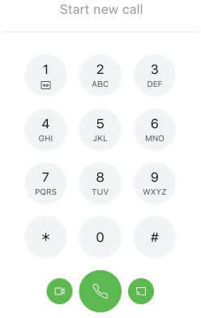Search
Add
Open Dialpad

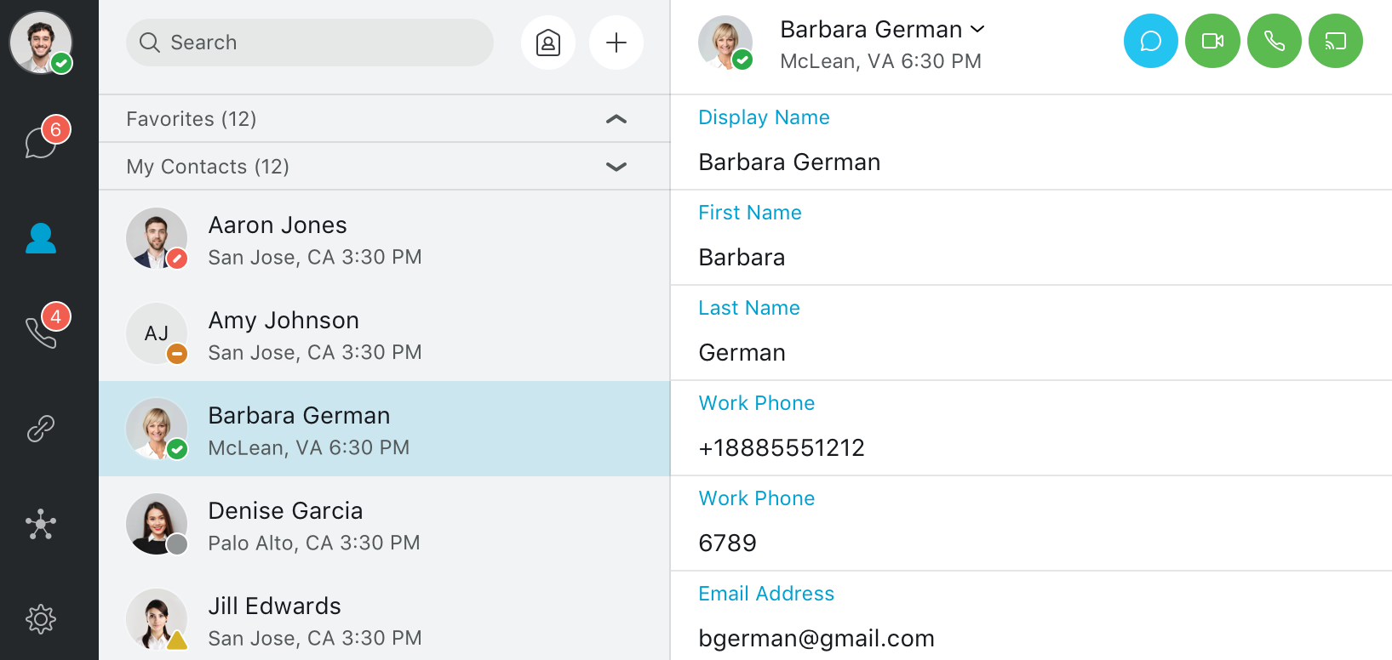Contacts
Contact list
Selected contact
Contact details
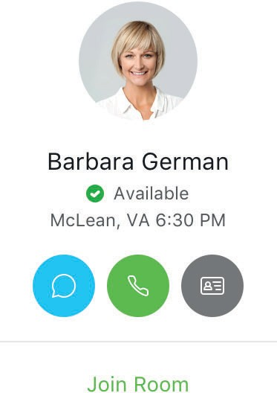Presence overlays

Contact card on hover

Start communicating from contact card
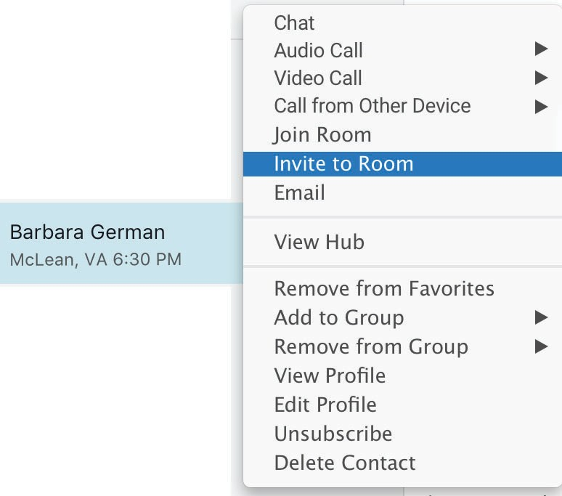or from contact details header

Shortcut menu to manage selected contact

Calls History Call state
Open voicemails Voicemail list Voicemail controls

In-call controls

Video call

Mute/ unmute
Camera on/o
Hold/ resume
Share

‘More’ menu

‘More’ End call

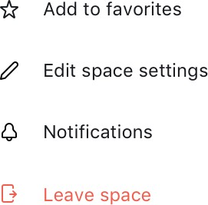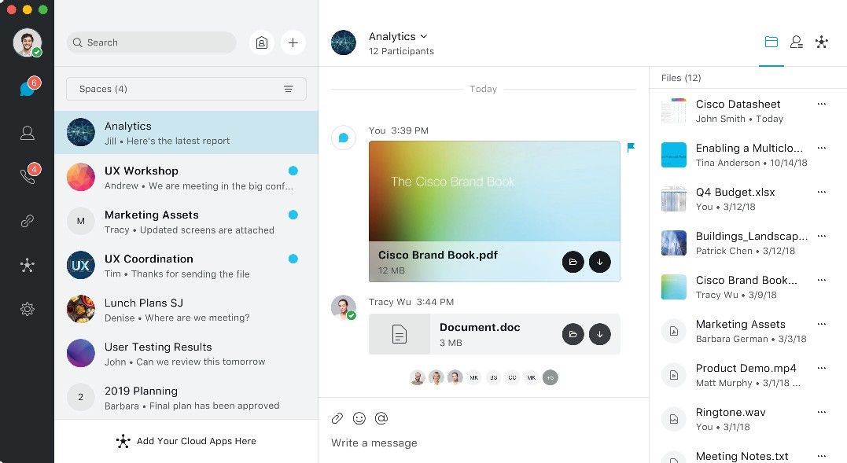Meetings Messaging and Spaces

Select the MyRoom icon to start a meeting in your room: Select the Chat icon to see
Change your interaction with

MyRoom

Status

Participants video In-call controls Selfview

MyRoom controls
Share

Meeting info (selected)
Hub
MyRoom controls

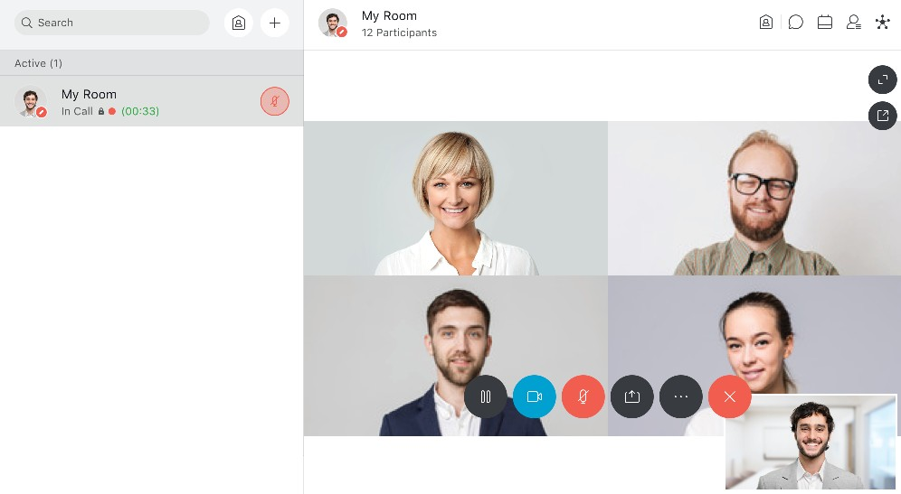Full-screen video Pop out video

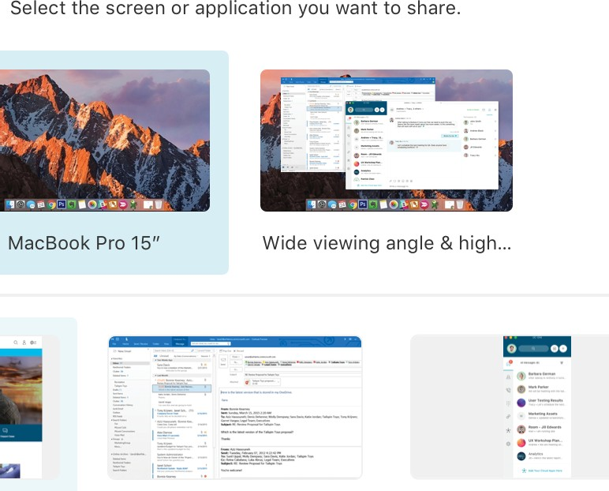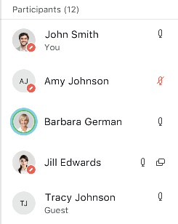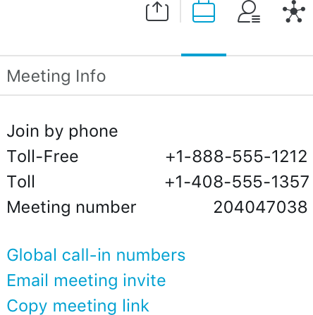Participants

Muted
Speaking Sharing

1:1 messages and group conversations in spaces:

Chat

Conversation list Active conversation Related information Write message

Message controls

Insert emoji Post a le
Type your message

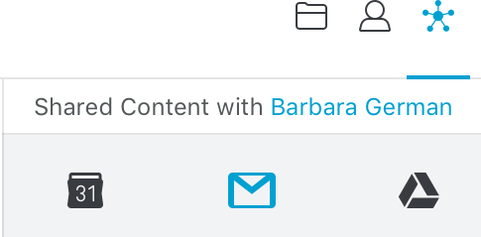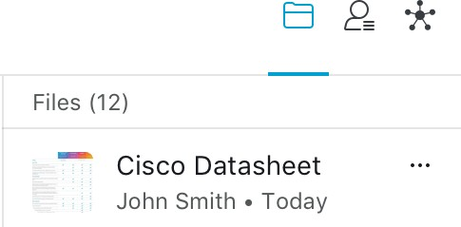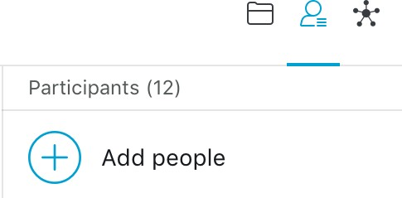Related activity
this space
Flag any or delete your own messages

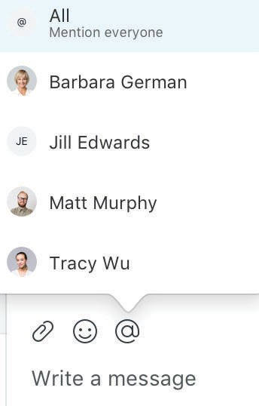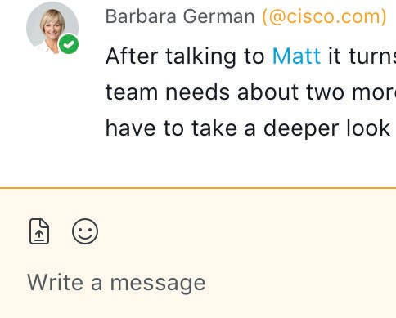Use @Name or @All to mention people in the space

External participants in conversation

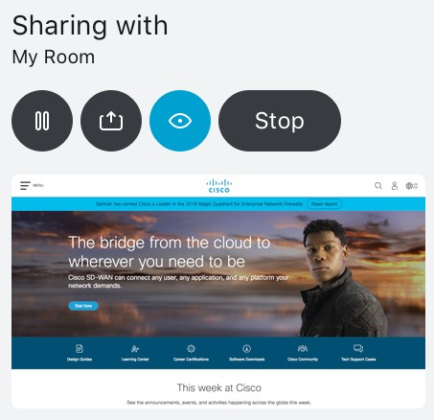Sharing controls
Files in this space People in this space Hub data in this space

