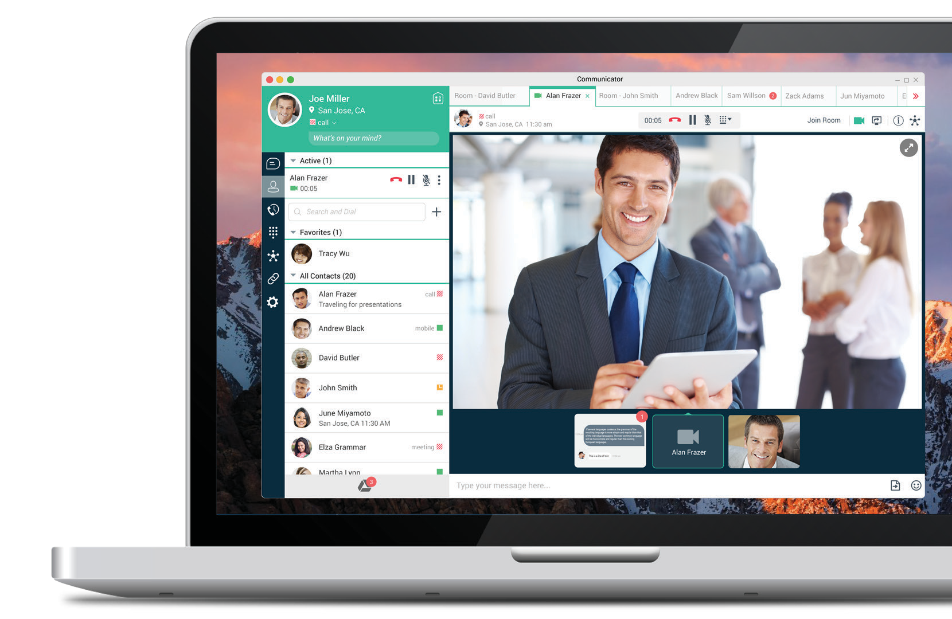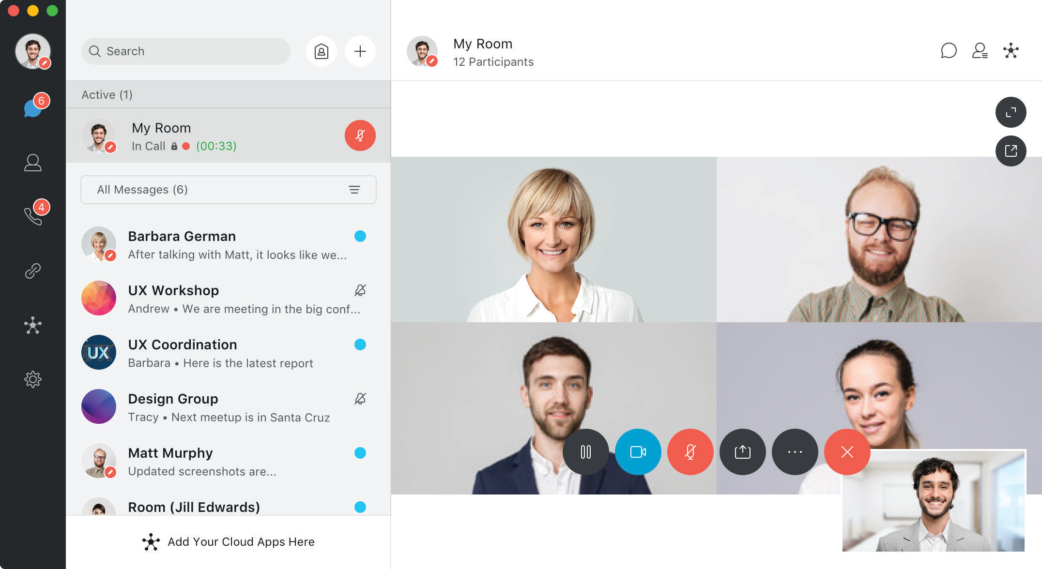E-book

UC-One

Your business communications are about to get a lot simpler.

1

E-book

We spend over two-thirds of our workday communicating with people. Why not do it right?

How much do
75%
of virtual teams are distracted during meetings
82%
admit to working on unrelated items during team calls
33%
of project leads cite communication as their greatest challenge
14%
report difficulty accessing expertise
Sources: 2017 Workplace Productivity and Communications Technology Report, Projects at Work, Society for Human Resource Management
2
we communicate?
69%
of our workday is spent on communications based activities

3hrs
a day is spent on phone calls and meetings

31
average number of people we interact with on a daily basis

The cost of ineffective communications
$15k
annual productivity losses per employee

15%
of our time is wasted

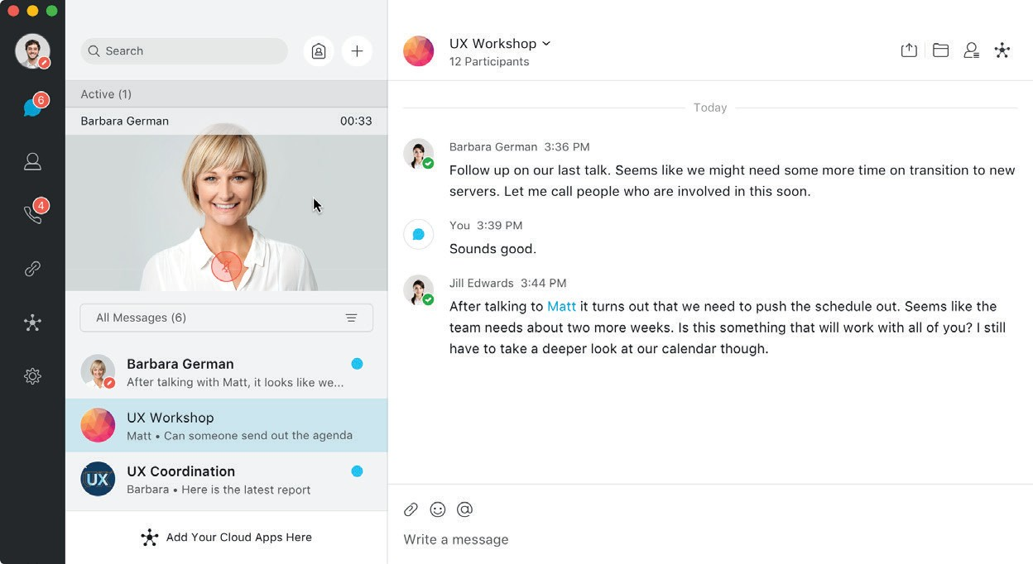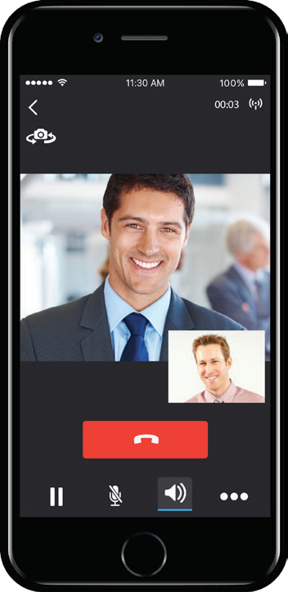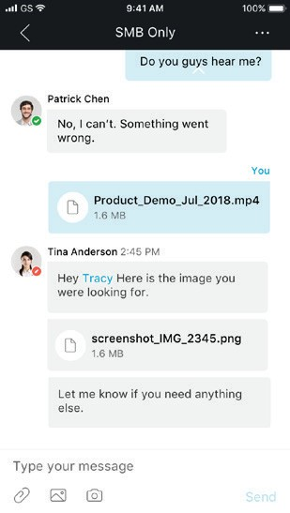EE--bbooookk

Simplify your communications with UC-One
UC-One helps teams work easy with full-featured, cloud calling, messaging, meetings, and team collaboration all in one app. It includes full HD voice and video conferencing, messaging, screen sharing, and file sharing in an easy-
to-use cloud app that integrates with your other cloud business apps

3

Work moves forward when people are calling, messaging, and meeting
Calling
Messaging
Meetings
Team Collaboration
4

E-book

Decisions, Decisions, Decisions
To make decisions quickly with the right people, no matter where they are, your employees need anywhere, any device real- time access to people and information.
A simple search finds people quickly in your contacts and directories and presence lets you know if they’re available for a call, chat, or meeting.
When you’re calling, meeting, or chatting with coworkers, UC-One finds all the content you have in common, to help you make decisions on time and move work forward.
Because UC-One is in the cloud, everything is accessible in an instant.

Sources: ZK Research - Cloud communications success depends on choosing the right service provider

EE--bbooookk

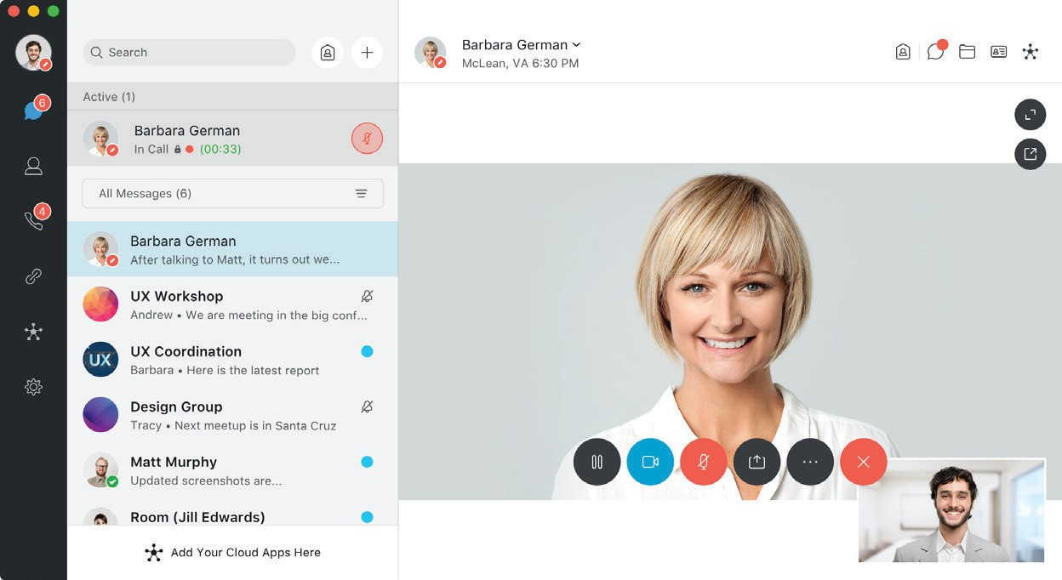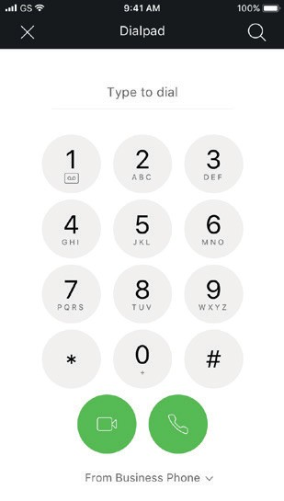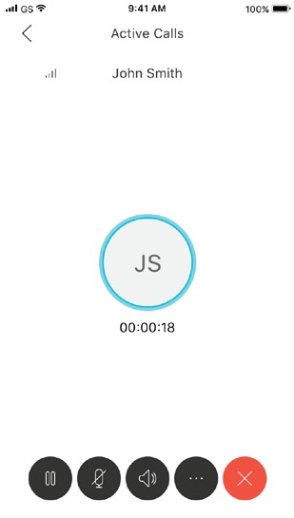Cloud Calling
If your business relies on predictable, reliable telephone calls, UC-One is for you.
UC-One provides the highest quality carrier grade capabilities to keep your employees connected and productive from any device – laptop, tablet, or smartphone.

UC-One is your phone system in the cloud:
» Make and receive your business calls on any device you choose
» Have your business calls dial a group of team members all at once or in sequence, until someone answers the call
» Have an auto-attendant route all your business calls
» Move a call in progress from your laptop to your smartphone and vice versa
» Access corporate directories so you can easily find company experts

» One number
» Wi-Fi calling
» HD video
» Presence

» Transfer, hold, hunt
» Any device
» Easy access to directories

5

EE--bbooookk

Messaging
UC-One is ideal for your direct and group chatting, so you can have quick and engaging communications with your co-workers.
Exchange messages in real-time to minimize email overload. Instantly share files with a simple drag and drop. With universal search find what you need
by searching across all of your people, messages and spaces. Everything is always available, so you never lose track of your chats and everything is safely archived.

» Direct and group chat
» File sharing
» Universal search
» History
» Easy access to emails and files

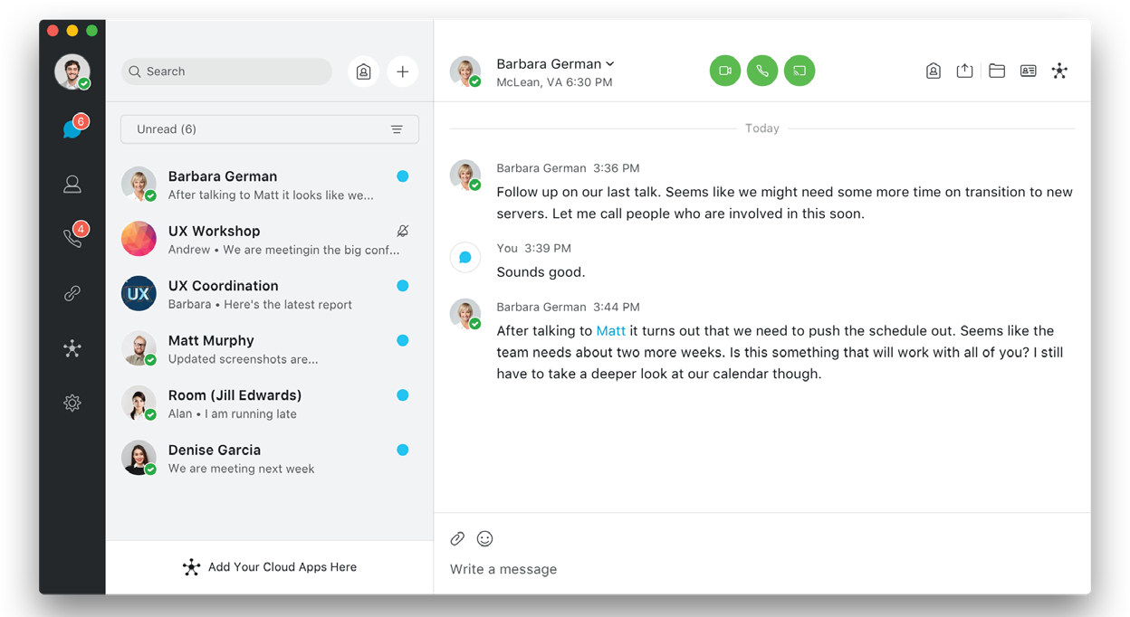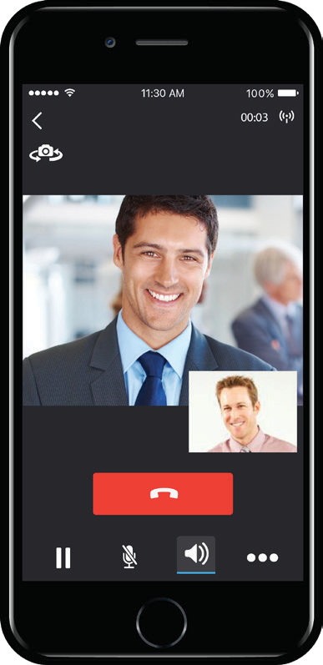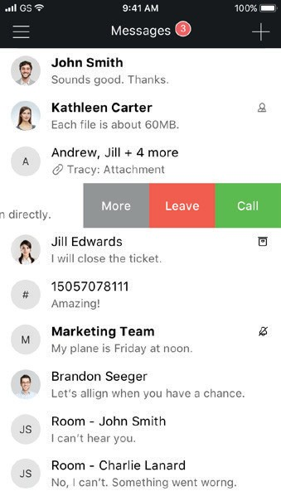
6

EE--bbooookk

Meetings
Meet face to face, wherever you are. UC-One allows you to invite colleagues and guests to your private My Room meeting space, without the hassles of dial-in numbers and passcodes.
It’s easy to host and join meetings from anywhere on your UC-One client. It’s so intuitive. Just one click gets you into
the meeting. Experience meetings with crystal clear high definition video and audio that makes you feel like you’re meeting in person.
Your teams are empowered to collaborate and engage just as effectively while apart, as when they’re all in the same room.

» Meeting room
» HD video
» Screen share
» Guest Collaboration

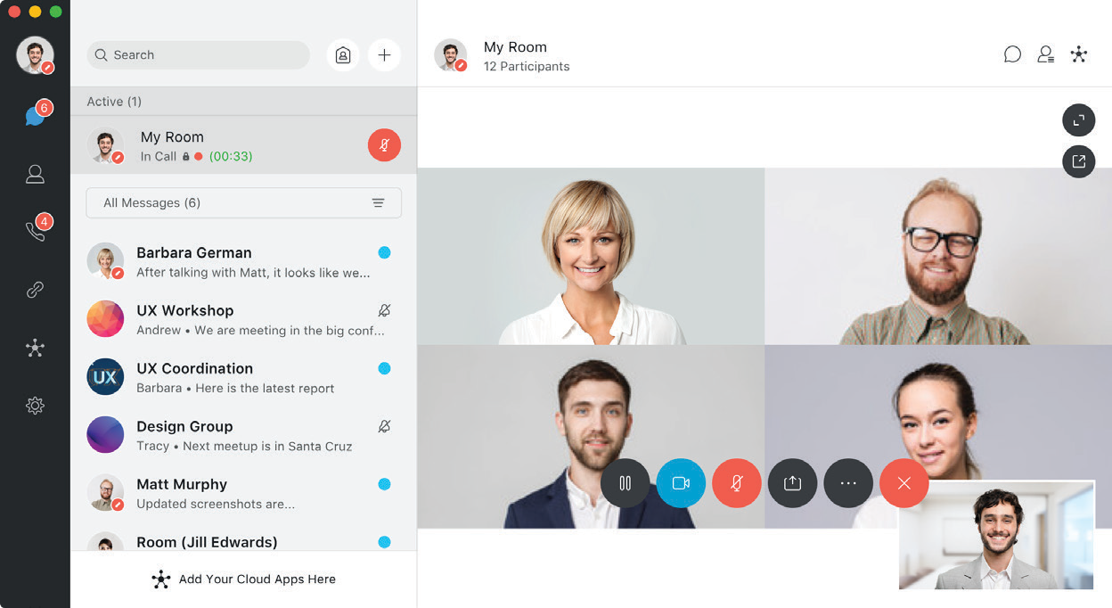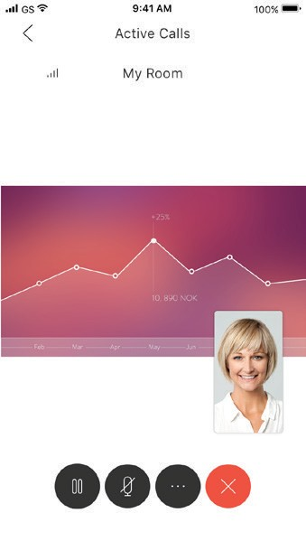
7

EE--bbooookk

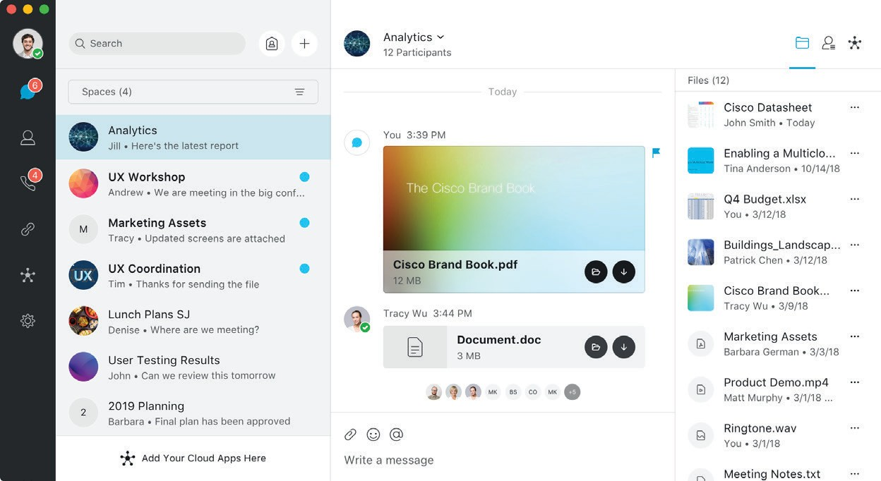Team Collaboration*
Introducing spaces in UC-One
Spaces give you a persistent, dedicated work space for your team’s
communications. Set up spaces around the people and projects that are aligned with your work, such as the team you work on, a presentation, or a product launch.
Call, message, meet, share files, or share your screen directly from within a space. Always-on persistence means your work is instantly saved and searchable, allowing you and your team to worry less about organizing and more about getting things done. Access everything from your mobile device to stay on track, even when
you’re away.

* Requires advanced team collaboration service. Contact us to learn more.

» Project spaces
» Group messaging
» File sharing
» Smart notifications

E-book

Outperform the competition
Companies that deploy UC experience a 72% increase in business.

How you benefit from UC-One

Enable teamwork
91% of IT executives see improved collaboration after UC is implemented.

Improve Productivity
Employees use one cohesive app to connect to people and content from anywhere.

UC-One

Enhance mobility
Employees take their conversations and files with them wherever they go.

Reduce costs and complexity
Pay a predictable monthly per-user fee and reduce IT
time, resources, capital outlay.

Respond faster
88% of UC buyers reported significantly faster problem resolution.

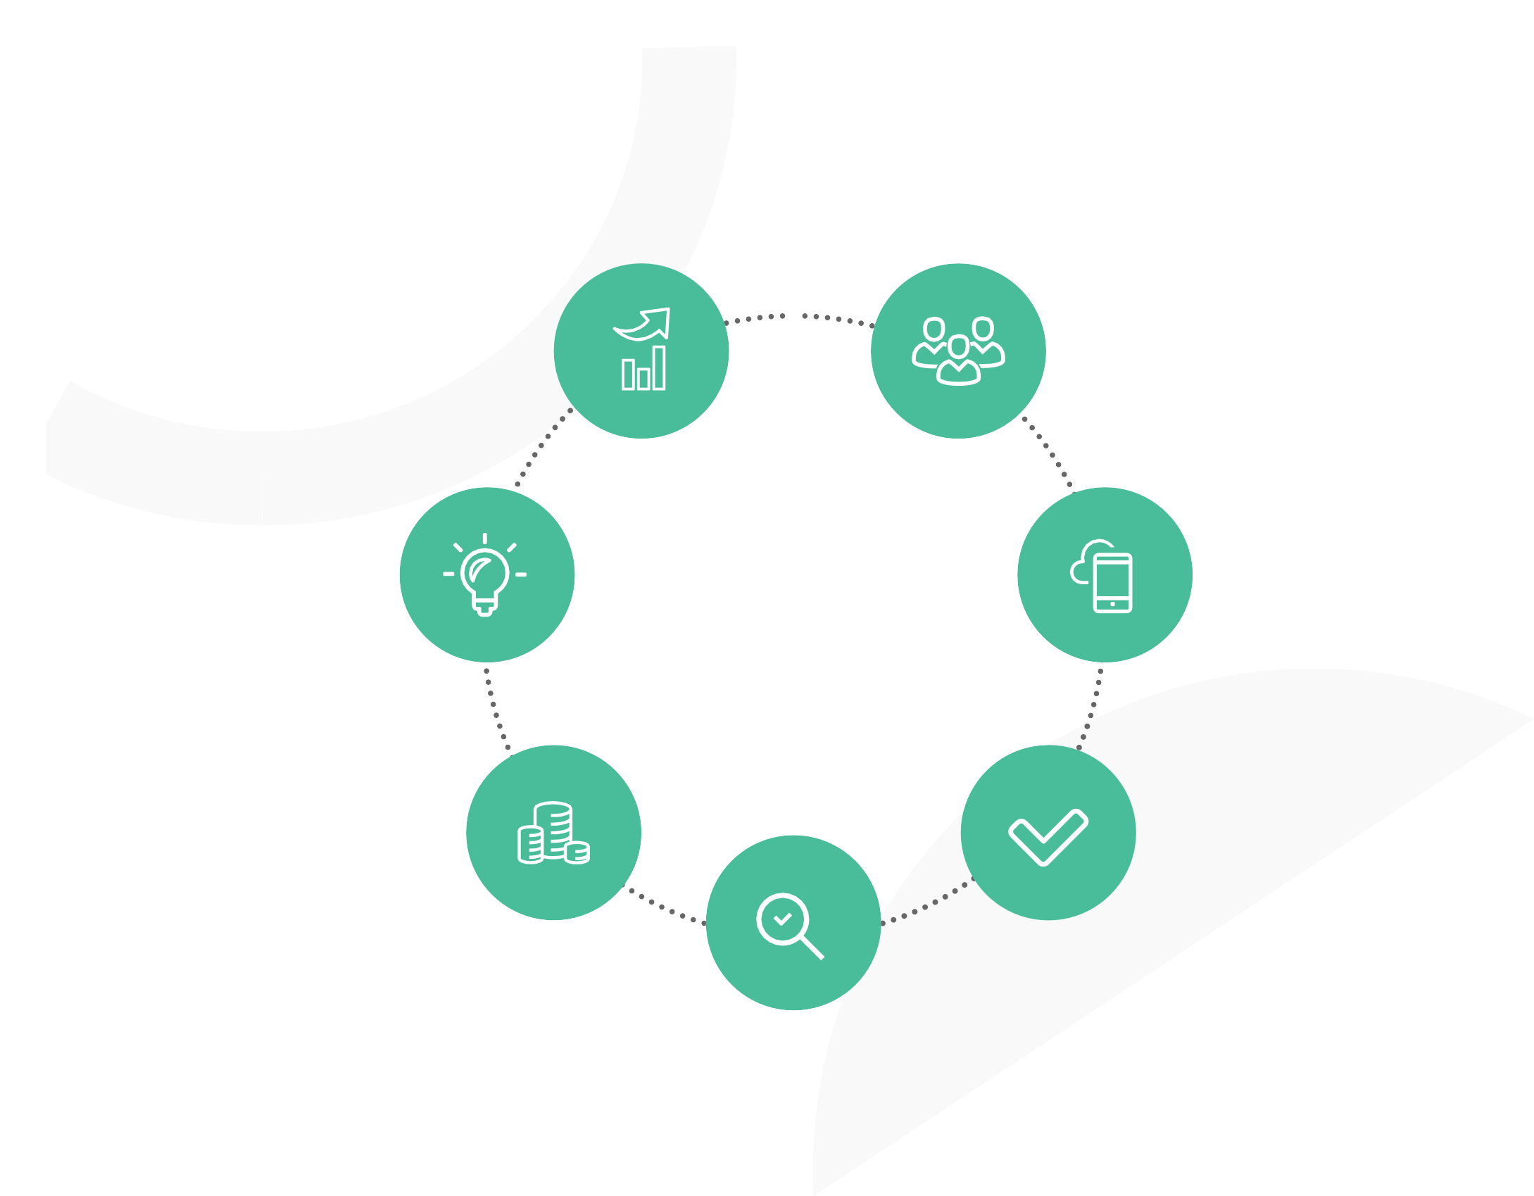Want to learn more? Contact us for a demo!

Minimize risk
Minimize unsanctioned apps
that introduce security exposures and increase IT costs.

Sources: Tech target 9

