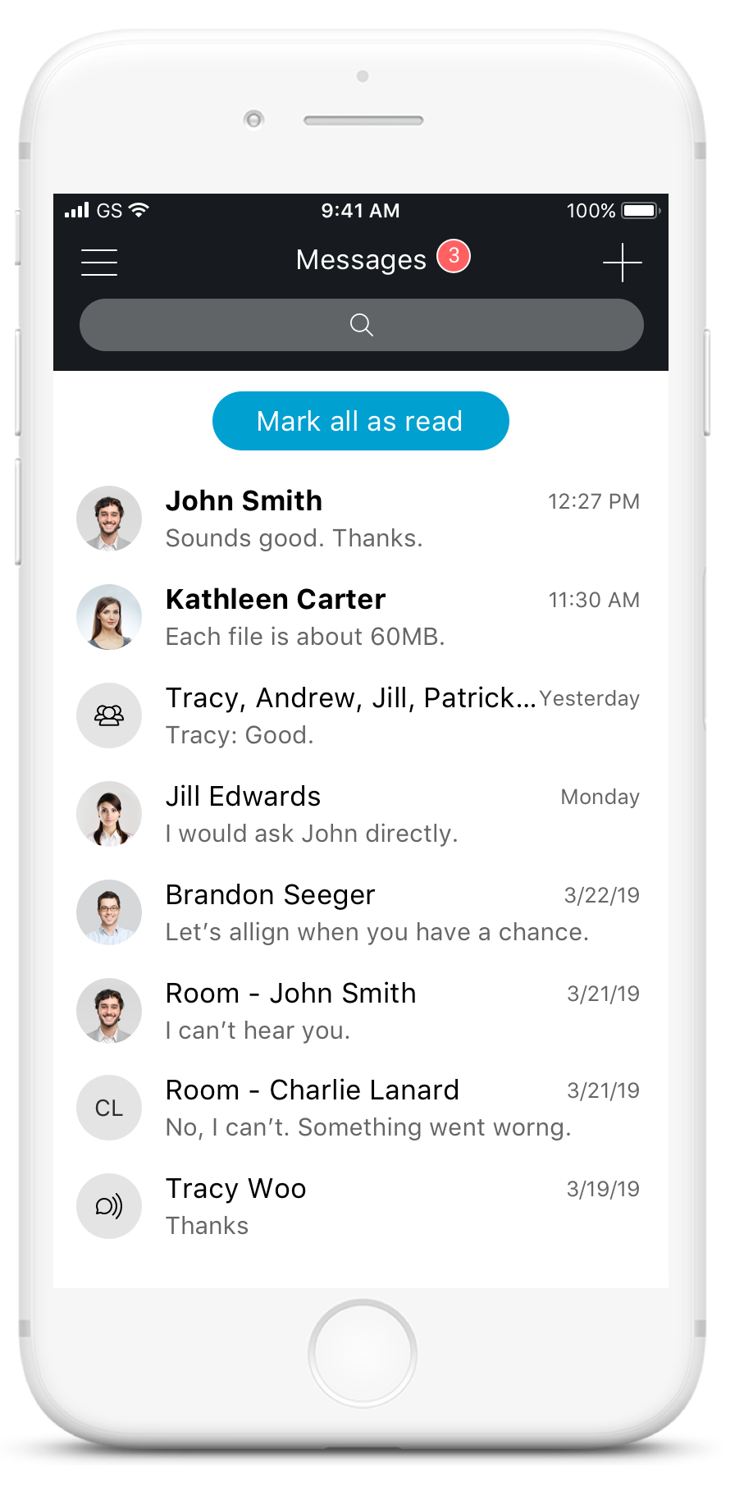Messages
1
2
3
4
5
6
7
8
1

Open side menu New message Search for messages Mark all as read Unread message
3
2
4
5
6
Group message Read message Date/time stamp
7
8

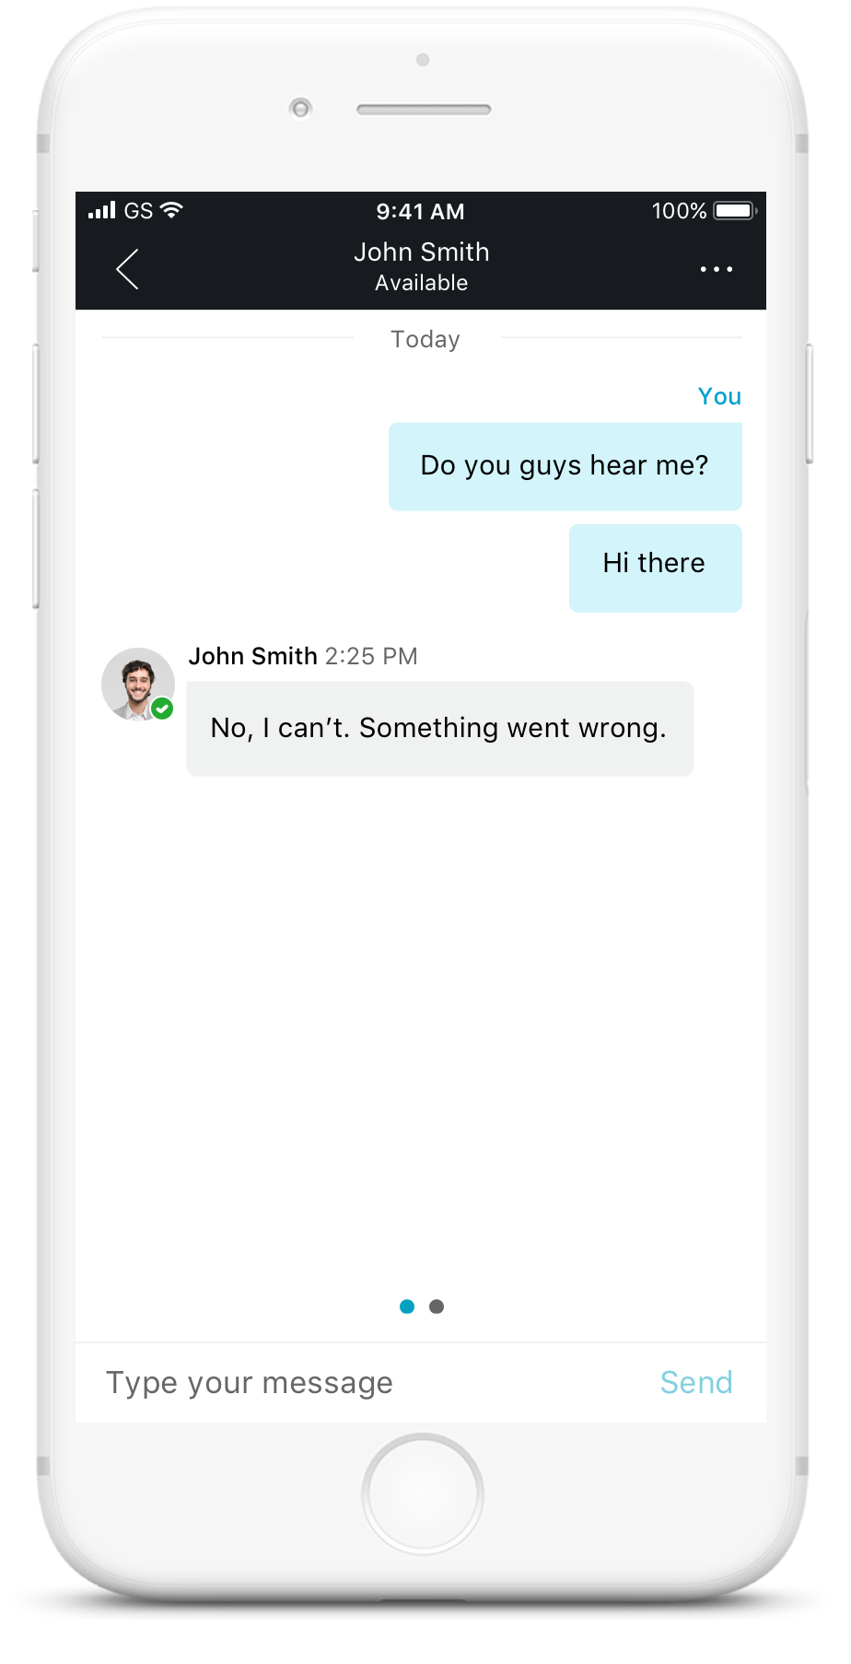Chat Thread
1
3
2
4
5
6

Tap to return to the previous screen
1

More menu to call, call room, view profile..etc
2

Date stamp
3

Outgoing message Incoming message Input field
4
5
6

Call History

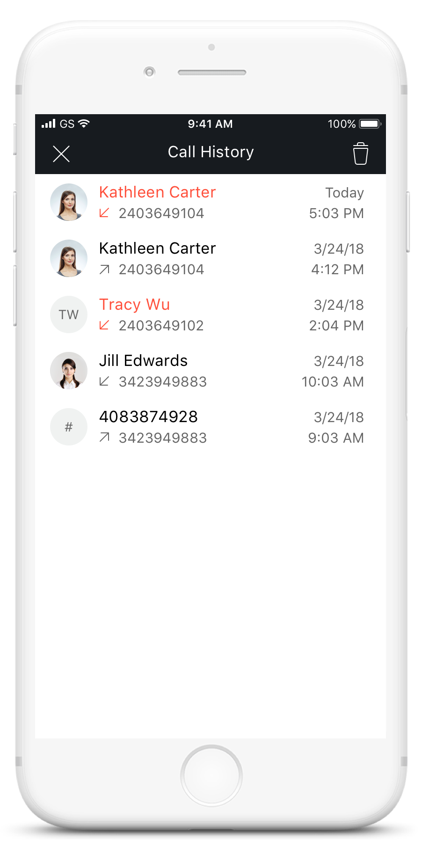Tap to close Call History menu Delete all
1
2
3
4
5
8
6
7
1
2
3
Missed call Placed call Jump to profile Received call Time/date of call
4
5
6
7
8
Call from unknown contact

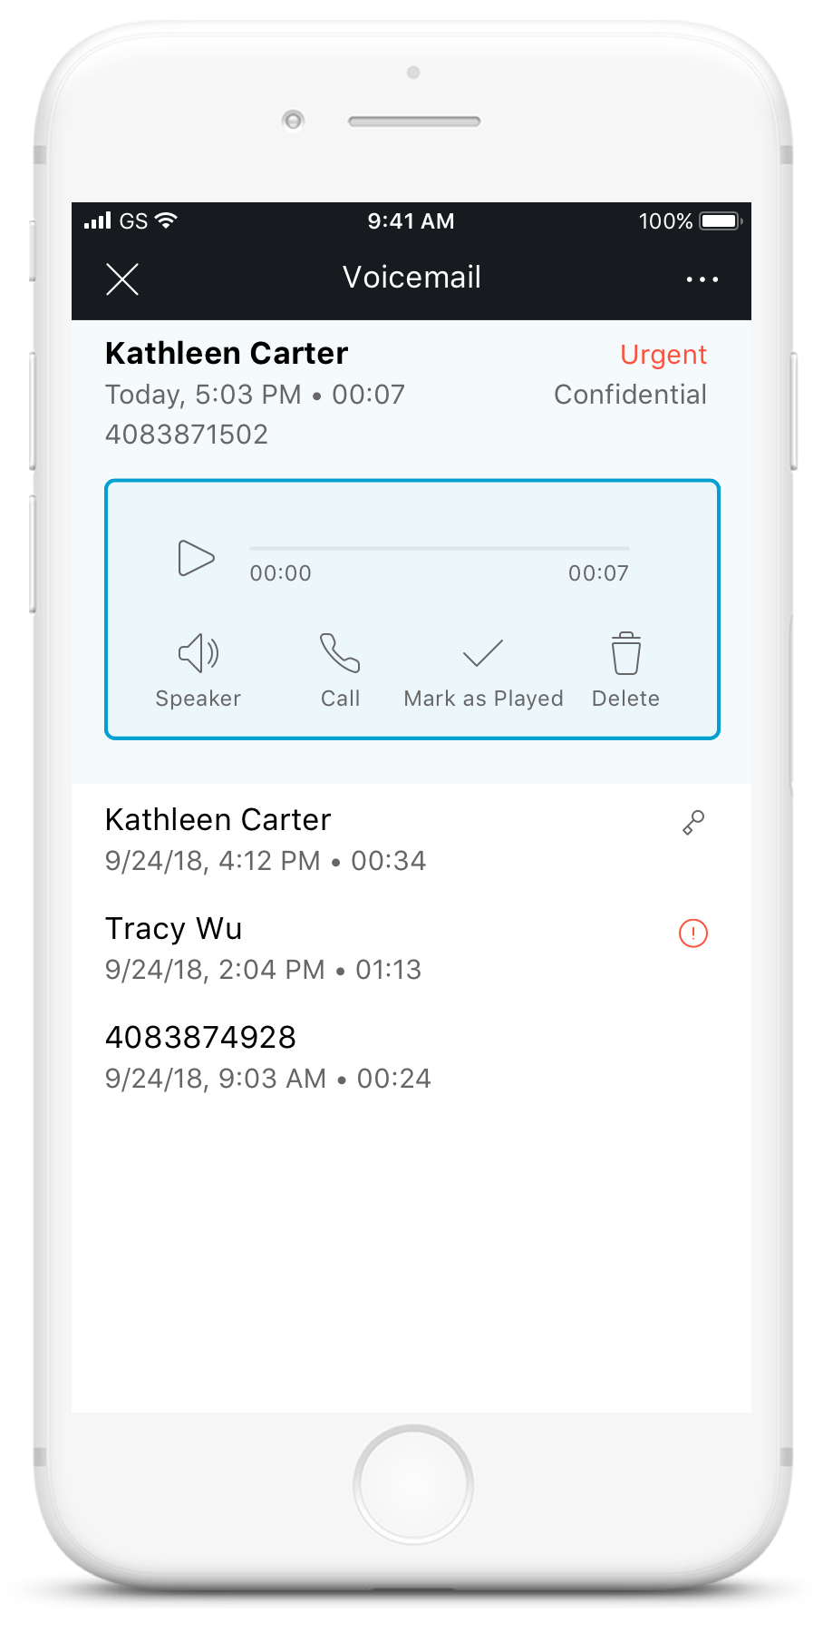Voicemail
1
3
2
4
5
6
7

Tap to close the Voicemail
1

More actions: Call Voicemail, View Voicemail Settings
2
New Voicemail with date, time, duration and
3
phone number

Urgent and confidential Play/Pause
4
5
6
Speaker, call, mark as new, delete Played Voicemail
7

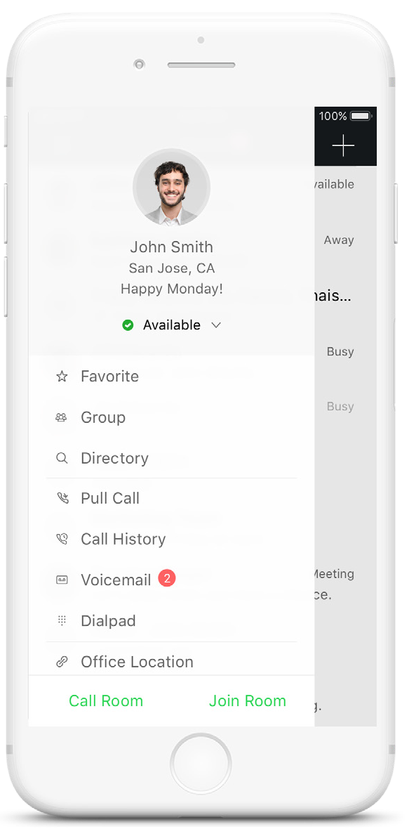Application Menu My profile
1
2

3
4

5
6
7
8

10
9
11
1
Favorite contacts Group of contacts Search for direcotry
3
2
4
5
Pull ongoing calls from other devices Call History
6
7
Visual Voicemail
Call any number from Dialpad (Long press on ‘1’ on the numeric pad calls your voicemail)
8
9
Weblink

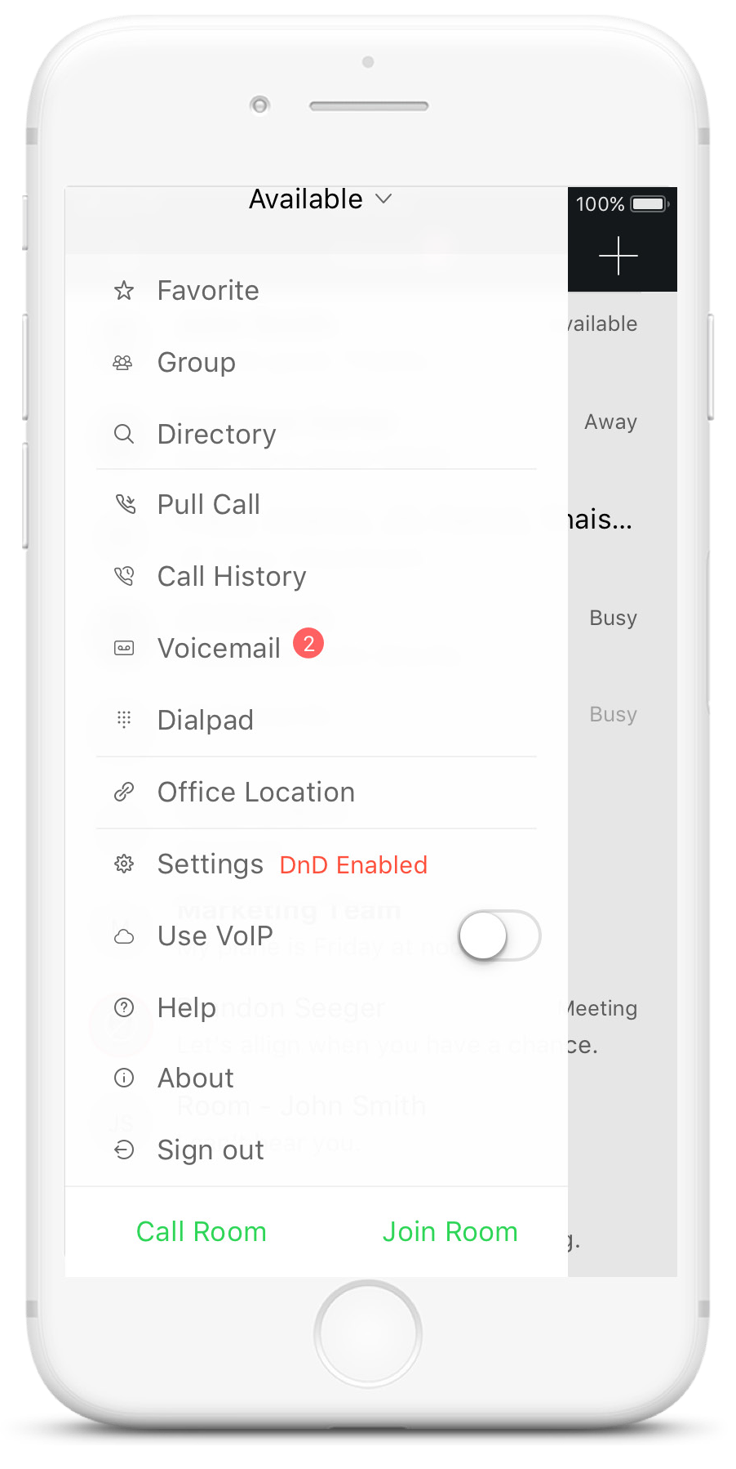Call My Room Join My Room
12
10
11
12
13
14
15
16
Settings (Do Not Disturb is turned on)

Use VoIP
13

Help (learn how to use the app)
14

About (find more information in About for the client version, license, and legal notices
15
16
Sign out of the app

In Call

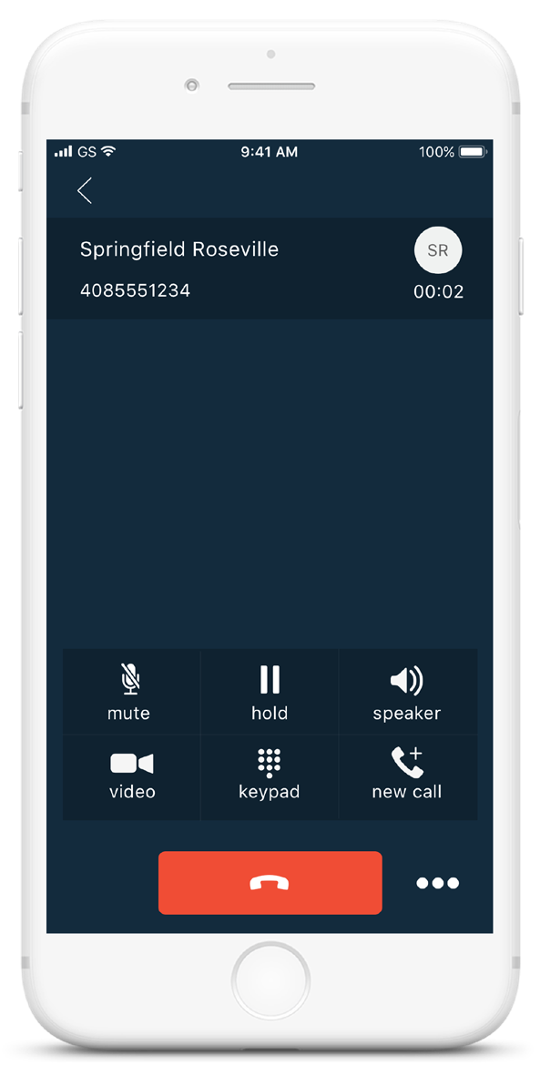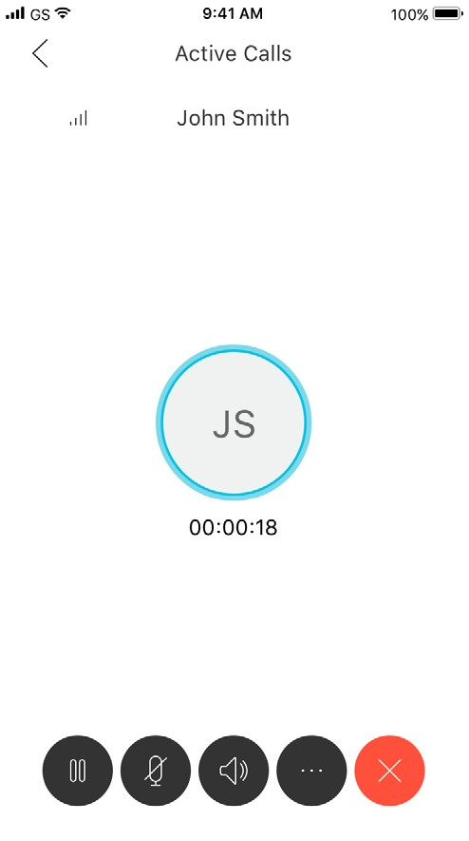Tap back to return the previous screen
1
1
2
3
4
5

Name, number
2
Call control actions: Hold/resume Mute/unmute
3
Audio source: Speaker/Bluetooth/Headset Keypad (DTMF entry)
Video New call

Hang up
4
More: Transfer Conference
5
Trasfer to mobile

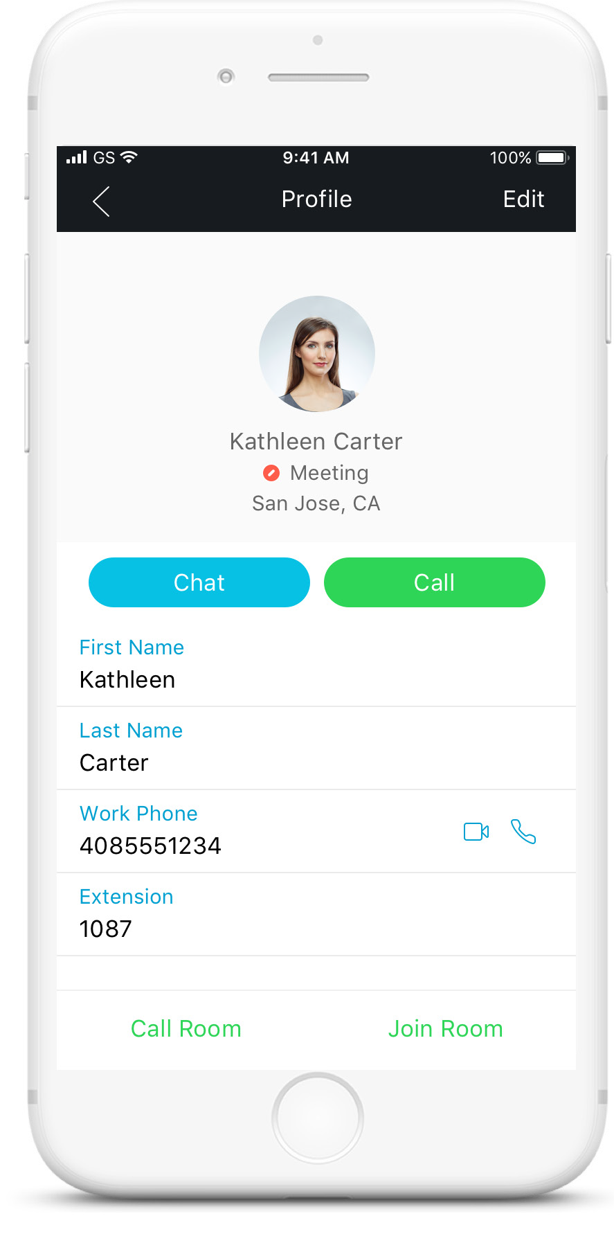Contact Profile
1
2
3

4
5
6

Tap to return to the previous screen Profile picture
1
2
3
Name

Chat
4

Call to this person’s primary number Call with video
5
6

