Solution Brief

Meetings in UC-One
Technology bringing people closer together

It’s rare to find a team that sits together in the same office, regardless of how big or small your business is. A recent survey of knowledge workers indicates that 79% always or frequently work in dispersed teams. For virtual teams to reach their highest potential, everyone must be mentally present and engaged. Yet 82% of people admit to working
on unrelated items during team calls. And 64% actually prefer to join from a mobile device.
This is especially true for millennials, who now make up almost half of our workforce.
When meetings are more interactive, issues like multi-tasking and lack of engagement can be significantly reduced, leading to higher team productivity.
» Video has been proven to increase trust, interaction, and understanding among distant colleagues. Viewing facial expressions and body language helps teams experience nonverbal cues, which often make up 93% of our communications.
» Sharing content during meetings is another way to make them more interactive, helping to promote brainstorming and accelerate project completion. Teams can share documents on the fly or share the latest breaking news, shortening review cycles
and streamlining business processes.
» Messaging during meetings provides
quick and immediate ways of communicating without interrupting the flow of the call. For people who are participating from noisy places and need to stay muted, messaging ensures they can actively participate, asking questions and voicing their opinions.
1

Solution Brief

UC-One My Room
UC-One includes an intuitive and secure virtual meeting room called My Room, where teams collaborate using HD audio, video, and screen sharing, all within a single
application. With just one click or tap, teams can host and join meetings from any of their UC-One clients to participate in an interactive multimedia collaboration session.

As a UC-One user, you have your own personal meeting room, which allows you to host an impromptu or scheduled meeting at any time, without worrying about third-party conference bridges or long dial-in numbers and passcodes. Scheduling meetings is easy. Simply invite participants to your meeting from your preferred calendar app and let them know it’s in your room. All they have to do is join your room from their client with one click. People outside of your company can be invited to join as guests. They simply download our easy app and enter in their name.

Here’s how it works
Whether a meeting is scheduled or impromptu, when it’s time to meet, simply click on your My Room meeting button to launch a meeting, or Join Room to participate in a
colleague’s meeting. Everyone is instantaneously part of the multimedia collaboration session.

2

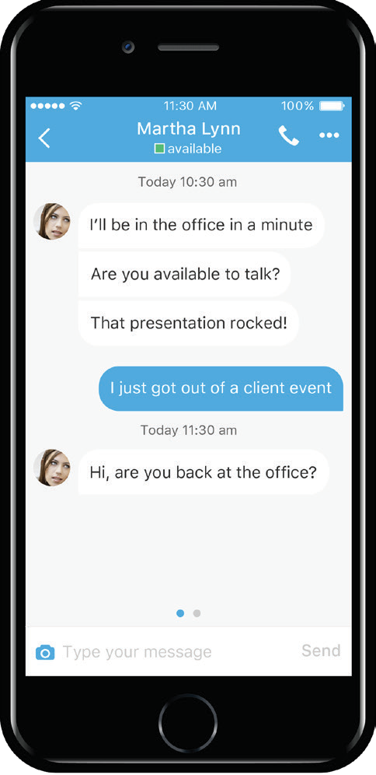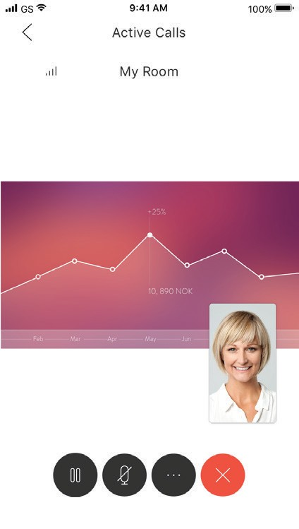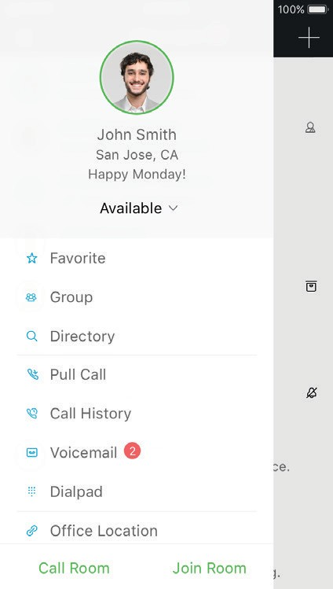

Solution Brief

HD video and audio
UC-One includes built-in high-definition video and audio. Whether you launch the call using audio or video, the video can be enabled or disabled at any time during the call. Up to 25 people can be a part of the audio/video call.

Moderating meetings
As the host/moderator of the call, you can mute participants if necessary or remove participants from the collaboration session.

Screen sharing
During the meeting anyone can share content from their desktop with everyone on the call. Simply click on the Start Sharing button and share your entire desktop, an application, or a specific document. Desktop users can view full screen, or zoom in and out for a better viewing. Content sharing within the meeting room eliminates the need to launch a separate web collaboration app, saving time and improving the
meeting’s efficiency.

Messaging
Everyone can participate in multi-party chat from their desktop or mobile device. This provides another way for teams to communicate and interact during the call, without interrupting the person who
is speaking.

3

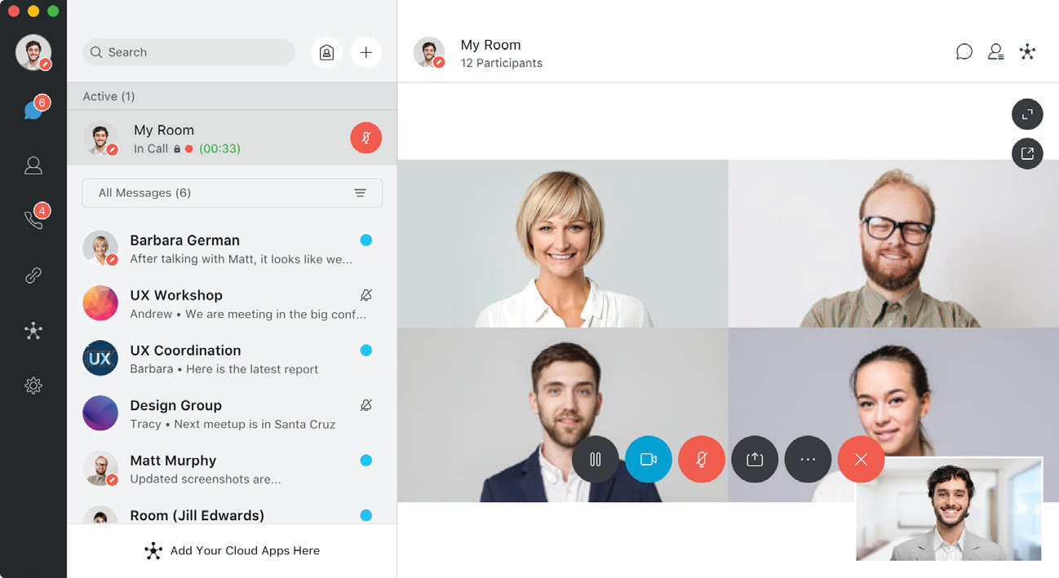Solution Brief

Joining while mobile
You can conveniently host or join
meetings from your UC-One mobile app without dial-in numbers or passcodes. One touch gets you into the meeting.

Joining via audio
When it’s only possible to
participate in the audio portion of the meeting, anyone can join from any phone by dialing the dedicated audio conference bridge number and ID.

Guest collaboration
Research indicates that 48% of teams
include external contractors, agencies, outsourcers, and other third parties. Simply invite them to the meeting and they can participate from their desktop, tablet, or smartphone.

4

Solution Brief

Meetings are better with UC-One

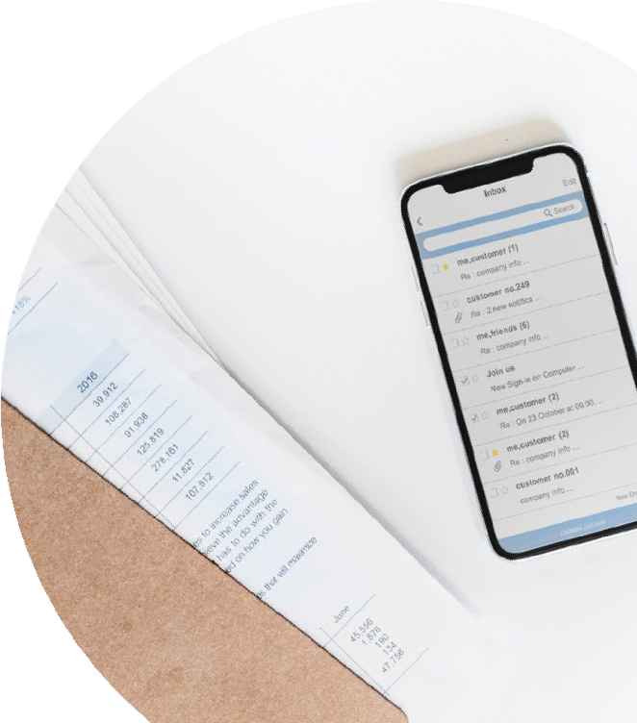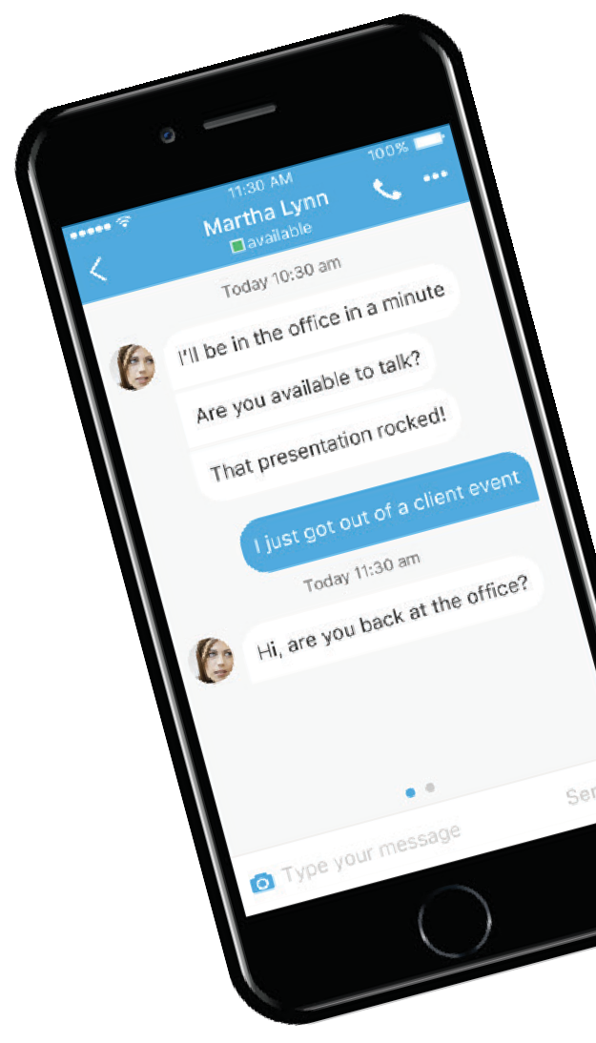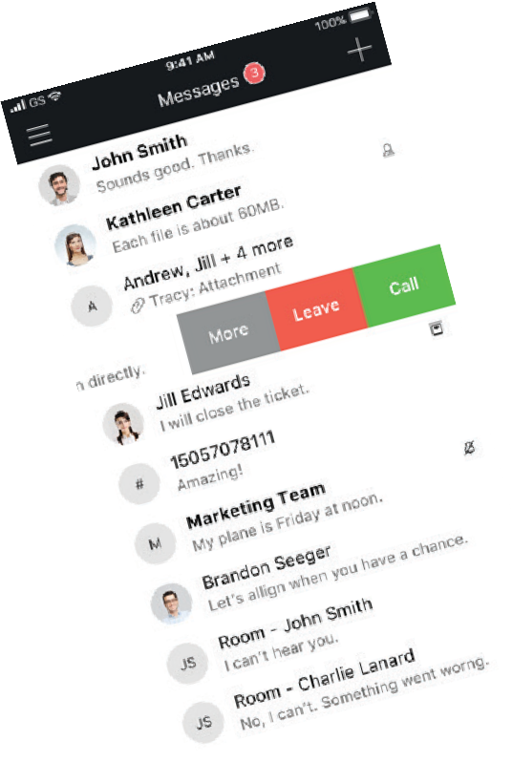» It’s easy to host and join meetings from anywhere. Join meetings from your UC-One client. It’s so intuitive. Just one click gets you into the meeting.
» It provides an exceptional HD video and audio experience. Teams are empowered to collaborate and engage just as effectively while apart, as when they’re all in the same room.
» Share content without launching a separate application. UC-One lets
you easily share your screen, so everyone can be on the same page while reviewing a document or an application on
your desktop.
» Invite guests to participate. Anyone outside your company can be invited to a meeting. Simply send them the secure link and they can join by downloading the app and entering their name.
» Engage in multi-party chat. You can easily participate in multi-party chat from
your desktop or mobile device.
» It’s mobile-friendly. Joining or hosting meetings from your smartphone or tablet keeps you productive while on the go.

